**The Growth of Lacrosse in The**

**United States**

Seth Gordon

Minghong Jian

Abstract

The game of lacrosse has grown exponentially through a majority of the United States. Over the past decade, lacrosse has become the largest growing sport for all levels of competition from youth to the professional level. An organization, named US Lacrosse, has been gathering data throughout all levels of lacrosse over the past decade to determine the trends in the popularity of the sport. Statistics were gathered and analyzed, as shown in the visualization presented in the below document, to further show the growth being experienced throughout a majority of the States. Few states have still not adopted the sport of lacrosse in some level, but the data shows the game will be adopted much greater over the next decade.

1. Introduction

The sport of lacrosse has seen a growth in popularity throughout all levels over the past decade. An 11-year period of net increase in players or fans has helped lacrosse become the fastest growing sport in the Unites States. The trend of this increase has cause many governing associations to believe the trend will continue into the next decade and further. Although some challenges are to be expected, plans are being set to help further improve and grow the game. Lacrosse has huge momentum behind it and is making notable moves to become a choice sport of the future.

1. Description of the Game

Lacrosse is an outdoor game in which players use long-handled sticks with nets for catching, throwing, and carrying the ball. The ball us made of rubber and commonly 3 inches in diameter. There are different types of lacrosse including men’s field, women’s field, and box lacrosse, but for this study, we will focus on men and women’s field lacrosse. Each type has multiple levels of the game associated to them including youth, high school, and collegiate. The professional level currently only features a male league. All levels of the game for both types (Excluding the youth level, which is smaller) have similar field dimensions with some variations in how the field is lined.

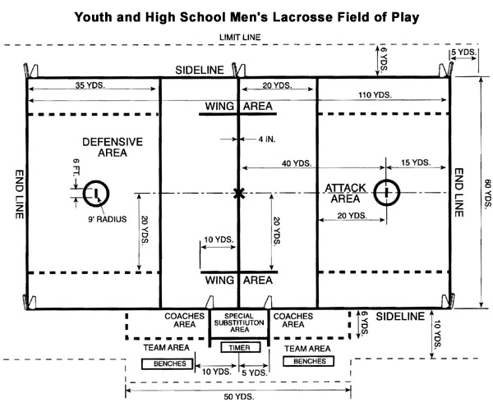

Figure 1: Men's Lacrosse Field Dimensions

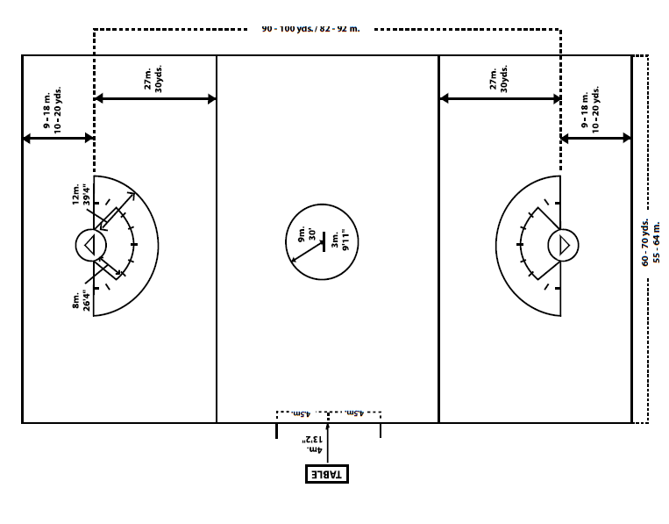

Figure 2: Women's Lacrosse Field Dimensions

A lacrosse field today is 110 yards long and 60 yards wide. The goal for both types is 6 feet tall by 6 feet wide and sits inside a 9-foot diameter circle, named the crease, which is 15 yards from the end line for the men’s game and 10-20 yards for the women’s game. The game consists of four main positions including defenseman, midfielders, attackers, and the goal keeper. In the men’s Version of the game the size of the stick differs with the position. Midfielders and attackman have a 3-foot long stick, and defenseman have a 6-foot long stick. Players are substituted throughout play during the game. Midfielders are often substituted in lines like in ice hockey because they run so much and need to rest. The goal of the game is to scores more goals than the opposing team.

1. National Governing Body of Lacrosse

The national governing body of men’s and women’s lacrosse is US lacrosse. US Lacrosse was founded January 1st, 1998 to help unify the national lacrosse associations to help maximize the number of players and resources available. The mission statement of the association is, “Through responsive and effective leadership, we provide programs and services to inspire participation while protecting the integrity of the sport.” From this statement, the association set goals to help make the sport safer, train and certify coaches and officials, create opportunities to play, elevate the sports visibility, pioneer national standards, and educate the lacrosse community. Beginning in 2001, US Lacrosse began to take a participation survey in order to measure the growth of the game. The US Lacrosse association currently staffs 80 full-time employees with volunteers joining every day. Encompassed in the association is 67 regional chapters throughout the nation to help improve and further the game. A Strategic Plan Committee was formed the summer of 2014 and has collaborated till the fall of 2015 to set a strategic plan up to 2020.

This strategic plan was developed within the context of the growth of the sport and the US Lacrosse infrastructure. The committee placed priority to four major goals including improving the national governing body, increasing the education of the game, Outreach and inclusion, and increasing the staff structure and culture. The goal to improve the national governing body is to serve as the preeminent leader in driving the growth of the sport throughout the United States and promoting a lifelong involvement with the sport. The goal to increase the education is to enhance the player experience by providing resources focused on developing and retaining physically, socially, and emotionally strong players. The goal of outreach and inclusion is to establish lacrosse programs in geographic areas in which the sport is not currently played. The implementation of this plan is believed to grow the game exponentially throughout all the states.

1. Growth of the Sport Throughout all Levels

In the past decade, lacrosse has become the fastest growing sport in the United States throughout the youth, high school, and college levels, while participation in other sports have begun to dwindle. Throughout the past few decades, the number of colleges that participated in having a men’s lacrosse organization grew from 172 to 350 and women’s lacrosse organizations grew from 144 to 470. The number of men who participated in the sport grew from 5,408 to 13,165, and the number of women who participated grew from 3,218 to 10,994. This growth is the highest amongst any other collegiate sport in the U.S. The states in the U.S. that have seen the largest growth in participation percentages of male and female athletes include Minnesota, Florida, Georgia, Ohio, Virginia, Michigan, California, Massachusetts, Pennsylvania, and Maryland. In previous decades, lacrosse was mainly known as a regional sport, but its popularity has begun to grow nationwide. All levels of the game, including youth, high-school, college, and pro, have seen a tremendous growth in participation in the past decade.

A. Youth Level

According to the Wall Street Journal, the rate of participation in traditional team sports has fallen in the early elementary demographic, but the number of children opting to play lacrosse has grown exponentially in the last decade. The youth level has seen the largest rate of growth of any other level. Youth lacrosse, which encompasses player’s 15 and under, has doubled in participation over the past decade. Although after the past few years, the growth rate for youth lacrosse has begun to plateau but still increase slowly increase. A large reason the game has grown so greatly was the growth of the youth game. The youth segment is possibly the fastest growing area of the sport due to overnight sports summer camps and club leagues. Young players join lacrosse camp and go to school and play on teams and once they have graduated from high school, they seek out other opportunities to play their sport. Those athletes turn into fans, and the cycle is perpetuated with more kids playing lacrosse with the eager support of a parent that played and were a fan of the sport.



Figure 3: Growth Map for Youth and High School Levels

1. High School Level

The popularity of lacrosse is highest at the high school level, where its popularity can be described as explosive. According to the US Lacrosse association and the National Federation of High Schools, between the years of 2009 to 2014, the participation in the sport of lacrosse for boys grew from 1,984 to 2,535 (A 27.8% growth rate), and for girls, grew from 1,780 to 2,336 (A 31.2% growth rate. Lacrosse has seen the highest level of growth throughout all sports at the high-school level. Even though lacrosse has seen the highest level of growth, there is still room for considerably more growth. US Lacrosse organization’s strategic plan is to implement the sport of lacrosse more widely through the states and the high schools throughout those States. The growing popularity in the high school level has only cause an increase of popularity in the collegiate level.

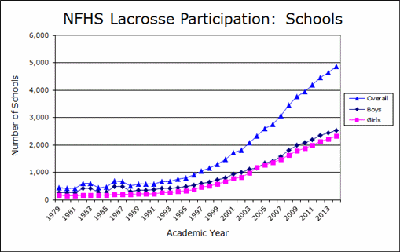

Figure 4: Trend Line of Growth of Number of High School Participation

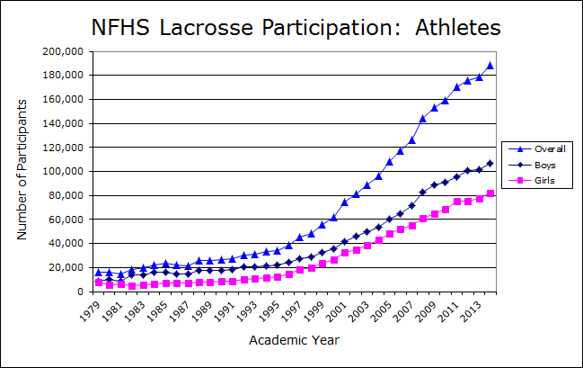

Figure 5: Trend Line of Number of High School Athletes

1. Collegiate Level

The collegiate level has also seen a fairly high level of growth in participation over the past decade. Growth across men’s and women’s lacrosse across all NCAA divisions notably outpaced all other sports from 2000-2014. Participation in women's lacrosse increased by 109 percent (225 teams to 470), and in men’s lacrosse, total participation is up 95 percent (203 teams to 350) over that period. The trend of this growth is expected to increase greatly over the next decade and further. Challenges will be face during this growing period.

A main struggle that has haltered the growth is the restrictions enforced by Title IX. Title IX is a law enacted in 1972 and designed to ensure equal opportunities in college athletics for both men and women, offers three prongs by which athletic departments can comply. The school can comply by continually expanding athletic opportunities or accommodating the interests of the underrepresented gender. However, historically, the first prong, which says athletic opportunities must equal the gender percentage enrollment of the undergraduate population, has become the standard to show compliance, since the other two prongs are difficult to measure. A large amount of universities throughout the country have lacrosse teams but as a club and not a varsity sport. US Lacrosse believes schools will continue to adopt lacrosse programs and help the game become a mainstream sport.

[](http://www.laxpower.com/participation/sponsorship03.gif)

[](http://www.laxpower.com/participation/participation03.gif)

1. Professional Level

Major League Lacrosse, the professional level of the sport was founded in 1999. Compared to the four other main professional league sports which include basketball, baseball, football, and hockey, who have a long lineage in the United States. Major League Lacrosse has seen the least amount of growth amongst the other levels, but the league is expected to see a large growth over the next decade. From the implementation of the league to the current year, the league has consisted of nine teams. The MLL has implemented an expansion initiative that will increase the number of teams to 16 over the next decade. Major League Lacrosse has implemented some innovative dynamics to the traditional game of field lacrosse that bring the sport into the next millennium. MLL rule changes include the addition of a two-point goal line located 16 yards from each goal and a 60-second shot clock. The hope in making these changes is to draw fans new and old to help grow the league.

1. Challenges

Although the game has been steadily growing for all levels of the game, challenges have occurred throughout. With the hurdles placed on growing the game, new opportunities became present to grow the game even further. There are still some states throughout the United States that have not experienced the same type of growth as others or have not seen any level of growth. A large challenge facing the growth of the game is how to implement the sport more highly into these states. Many efforts are beginning to be implemented in order to further the growth of the game in these states including travelling lacrosse camps or leagues beginning to be formed.

1. Conclusion

Lacrosse has become the fastest growing sport in the United States. The growth trend is only expected to continue over the decade and further. Many organizations and committees have been formed to assist in the game’s growth while also helping to improve it. Lacrosse has huge momentum behind it and is making notable moves to become a choice sport of the future.

References

[1] US Lacrosse, US Lacrosse – The National Govering Body of Lacrosse, 2015 <http://www.uslacrosse.org/>

[2] US Lacrosse, 2016 - 2019 US Lacrosse Strategic Plan, 2016, <http://www.uslacrosse.org/Portals/1/documents/pdf/about-us-lacrosse/2016-strategic-plan.pdf>

[3] Lacrosse Magazine, Lacrosse: Fastest-Growing NCAA Sport with Top Grad Rates, 2015, <http://www.laxmagazine.com/genrel/110915_lacrosse_is_fastest_growing_sport_with_top_graduation_rates>

[4] Sports Networker, Lacrosse Is The Fastest Growing Sport In America? 2015, <http://www.sportsnetworker.com/2014/11/13/lacrosse-is-the-fastest-growing-sport-in-america/>

[5] Lacrosse All-stars, The Remarkable Growth of Lacrosse in America, 2015, <http://laxallstars.com/the-remarkable-growth-of-lacrosse-in-america/>

[6] LAXPower, Growth of NCAA College Lacrosse, 2014, <http://www.laxpower.com/common/participation13.php>

[7] Berkshire, Statistics of Girls and Boys Lacrosse Participation in the United States, 2015, <http://www.berkshirelacrosseacademy.com/2015/12/09/statistics-of-girls-and-boys-lacrosse-participation-in-the-united-states/>